# AI ASSISTED CODING

# ASSIGNMENT 5.4

NAME:S.VRINDHA REDDY

HALL NUMBER: 2403A51255

BATCH:11

PROMPT-1: Write a Python script that collects user data such as name, age, and email. Add inline comments explaining how to anonymize or protect sensitive data (e.g., hashing emails, not storing passwords in plain text).

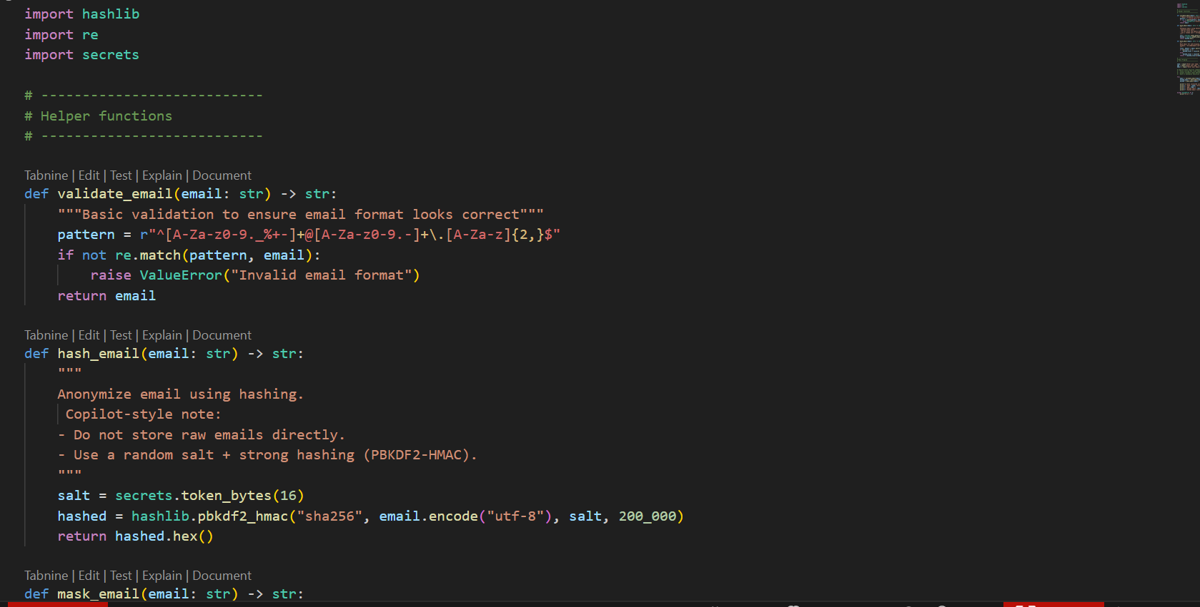

OUTPUT:

PROMPT-2: Generate a Python function for sentiment analysis using a library like Text Blob. Then add inline comments explaining how to identify and reduce potential biases in the dataset (e.g., balancing data, removing offensive or biased terms).

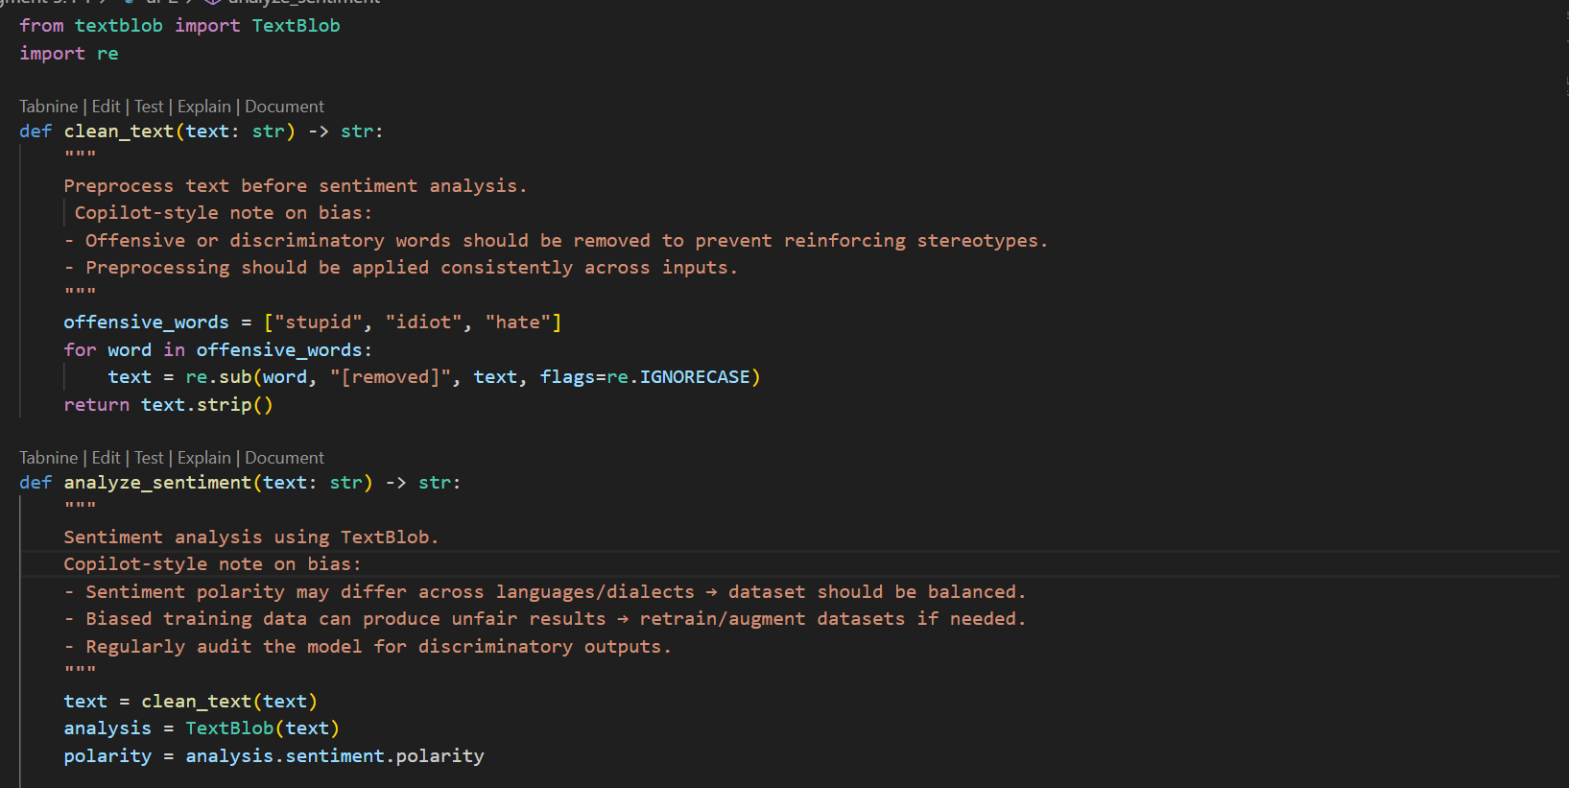

OUTPUT:

PROMPT-3: Write a Python program that recommends products based on user history. Ensure the code includes transparency (show why recommendations are made), fairness checks (avoid favouritism toward certain products), and a way for users to give feedback on recommendations.

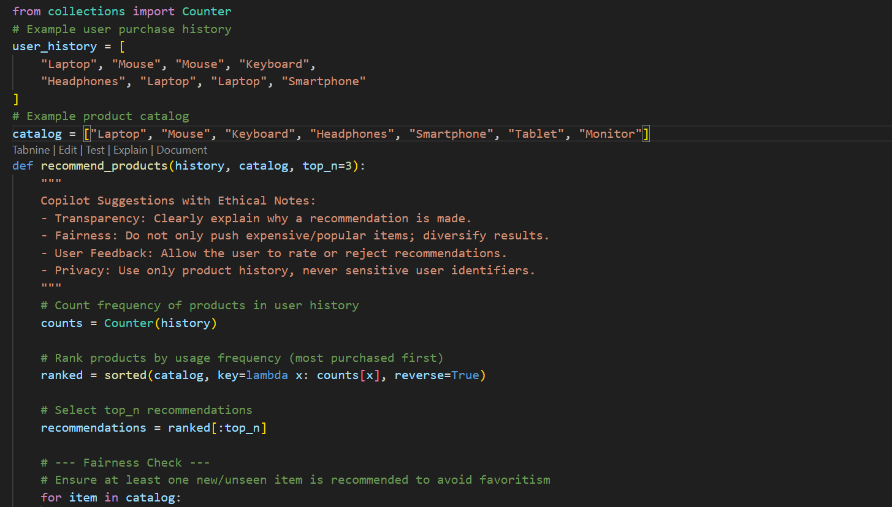

OUTPUT:

PROMPT-4: Generate Python logging functionality for a Flask web application.

Make sure logs do not record sensitive information such as passwords, emails,

or personal identifiers. Add comments explaining ethical logging practices.

OUTPUT:

PROMPT-5: Create a simple machine learning model in Python using scikit-learn. Then add inline documentation or a README section that explains responsible usage of the model, accuracy limitations, and fairness considerations in deployment.

OUTPUT:

